Home Assignments Week 1 – Day -02 -Siva
1)Vision models from different service provides (other than groq)
2)Try with meta chat in whatsapp
3)Check the cutoff date for Chatgpt,Qwen and Deepseek
4)Search for a Testscript or testcases with Thinking and normal model in chatgpt,Qwen and deepseek
(any domain or your office app)
5)Use the tokenizer to calculate the tokens for different prompts (with space ,with special characters without space etc)
https://platform.openai.com/tokenizer
6)From Openrouter ai --Extract the values of
1)Context window
2)Input tokens(with price)
3)Output token (with price)
For
openai/gpt-oss-120b
openai/gpt-4o-mini
openai/gpt-5.2
anthropic/claude-sonnet-4.5
anthropic/claude-opus-4.5
anthropic/claude-haiku-4.5
google/gemini-2.5-flash
google/gemini-3-pro-preview
google/gemini-2.0-flash-001
qwen/qwen3-235b-a22b-2507
qwen/qwen3-vl-235b-a22b-instruct

https://platform.openai.com/docs/models

- Vision models from different service provides (other than groq)
Qwen | Claude | Gemini | Llama | Chat GPT
Qwen3-VL-Plus | Sonnet | Gemini 3 Pro | Scout | GPT 5.1
Qwen3-VL-Flash | Opus | Gemini 1.5 Pro | Maverick | GPT 5.1 Thinking
Qwen3-Omni-Flash | Haiku | Gemini 1.5 Pro |  | GPT 5.2 Pro

- Try with meta chat in whatsapp
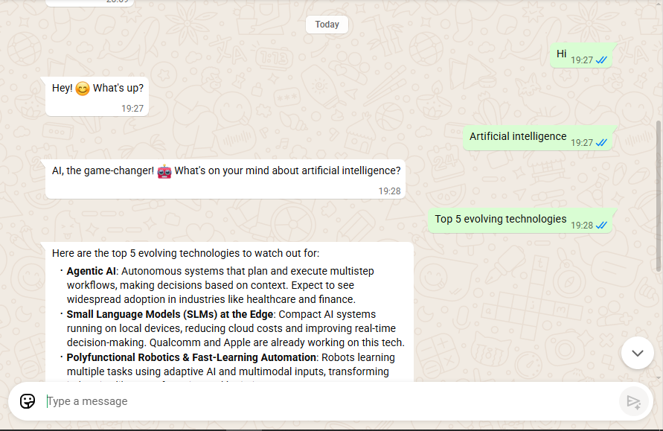
Got a best result

3.CUT OFF DATE

Chat GPT | Qwen | Deepseek | Meta
Jun-24 | Jun-24 | Cutoff date notdocumented publicly | August-2024

4.Search for a Testscript or testcases with Thinking and normal model in chatgpt,Qwen and deepseek
(any domain or your office app)
It generates test cases in different way.

5)Use the tokenizer to calculate the tokens for different prompts (with space ,with special characters without space etc)
https://platform.openai.com/tokenizer

Prompt | Token | Chars
Top 5 evolving Technologies | 5 | 27
Top5 evolvingTechnologies | 5 | 25
Top 5 evolving Technologies 213 | 7 | 31
Top 5 evolving Technologies %$^ | 8 | 31
Top 5 evolving Technologies 123^&* | 10 | 34

6)From Openrouter ai --Extract the values of
1)Context window
2)Input tokens(with price)
3)Output token (with price)

No. | Model | Context Window | Input Cost ($ / M tokens) | Output Cost ($ / M tokens)
1 | openai/gpt-oss-120b | 131,072 | $0.02 | $0.10
2 | openai/gpt-4o-mini | 128,000 | $0.15 | $0.60
3 | openai/gpt-5.2 | 400,000 | $1.75 | $14.00
4 | anthropic/claude-sonnet-4.5 | 1,000,000 | $3.00 | $15.00
5 | anthropic/claude-opus-4.5 | 200,000 | $5.00 | $25.00
6 | anthropic/claude-haiku-4.5 | 200,000 | $1.00 | $5.00
7 | google/gemini-2.5-flash | 1,048,576 | $0.30 | $2.50
8 | google/gemini-3-pro-preview | 1,048,576 | $2.00 | $12.00
9 | google/gemini-2.0-flash-001 | 1,048,576 | $0.10 | $0.40
10 | qwen/qwen3-235b-a22b-2507 | 262,144 | $0.071 | $0.463
11 | qwen/qwen3-vl-235b-a22b-instruct | 262,144 | $0.12 | $0.56

